**COSC 3380**

**Name: ______________ Seat# ___**

**Project 3:**

**(100 points.)**

**(Due date found in the COSC 3380 Detailed Syllabus!)**

Use the **COSC3380 Database** created in Project 2.

**Part 1.** **Stored Procedures**

**1.**

a. Create a simple procedure **ProductLineSale**, to be used by that will set a sale price to the existing Product table in the **COSC3380 Database** by adding a new column, SalePrice DECIMAL (6,2), that will hold the sale price for the products:

The **ProductLineSale** procedure should scan all rows of the **Product** table. Products with a ProductStandardPrice of $400 or higher are discounted 10 percent, and products with a ProductStandardPrice of less than $ 400 are discounted 15 percent. As with other database objects, there are Oracle SQL commands to create, alter, replace, drop, and show the code for procedures.

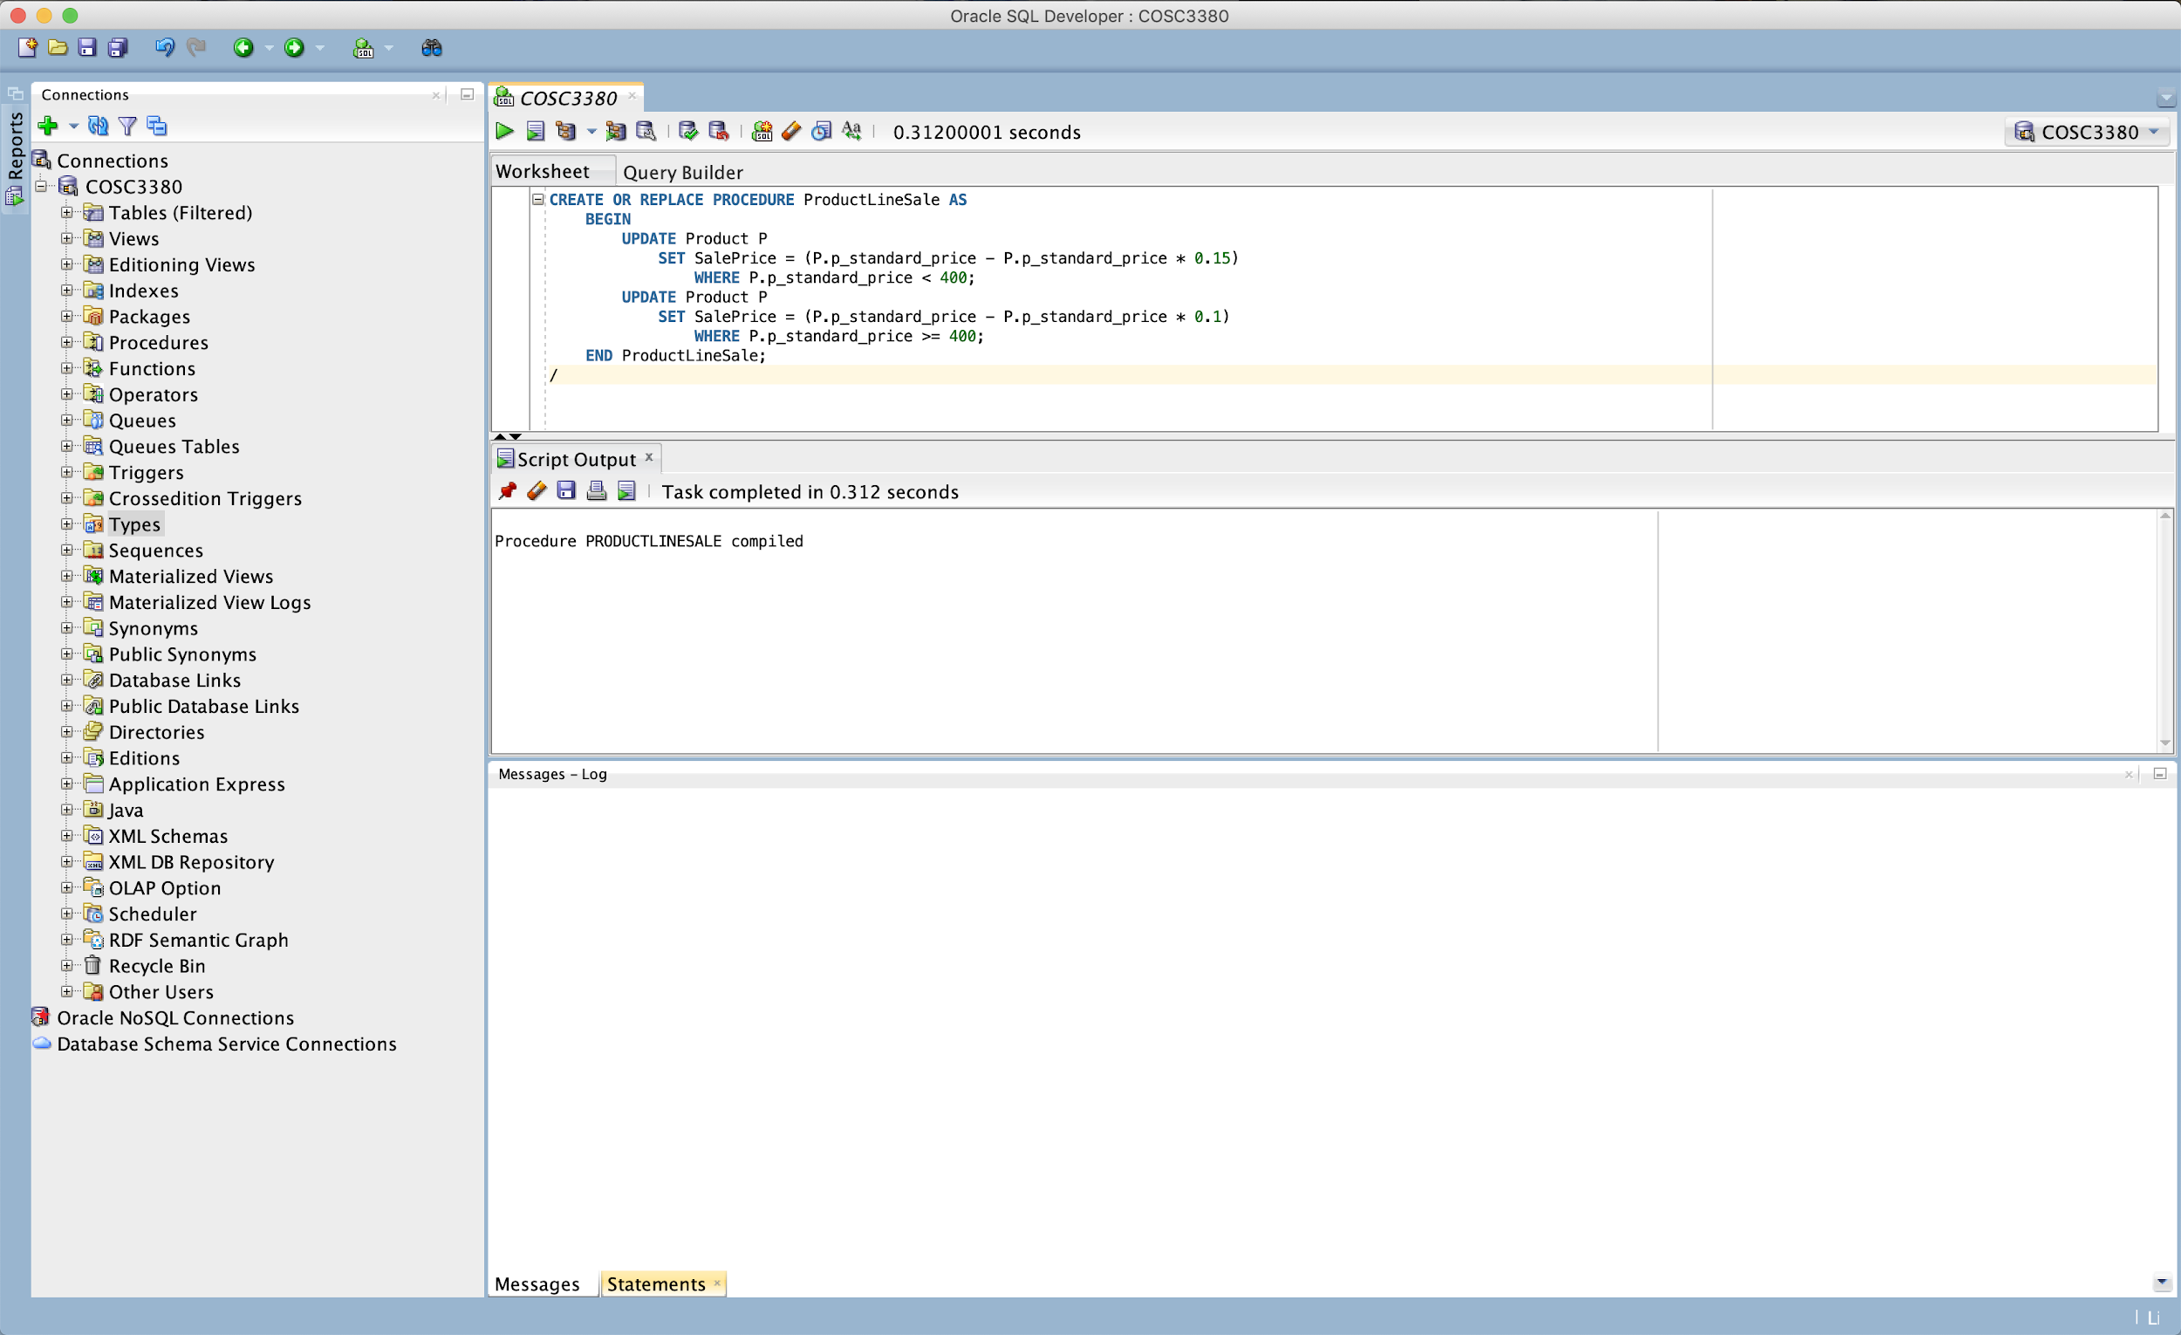

b. Run the **ProductLineSale** procedure in Oracle.

c. Display the contents of the **PRODUCT** table.

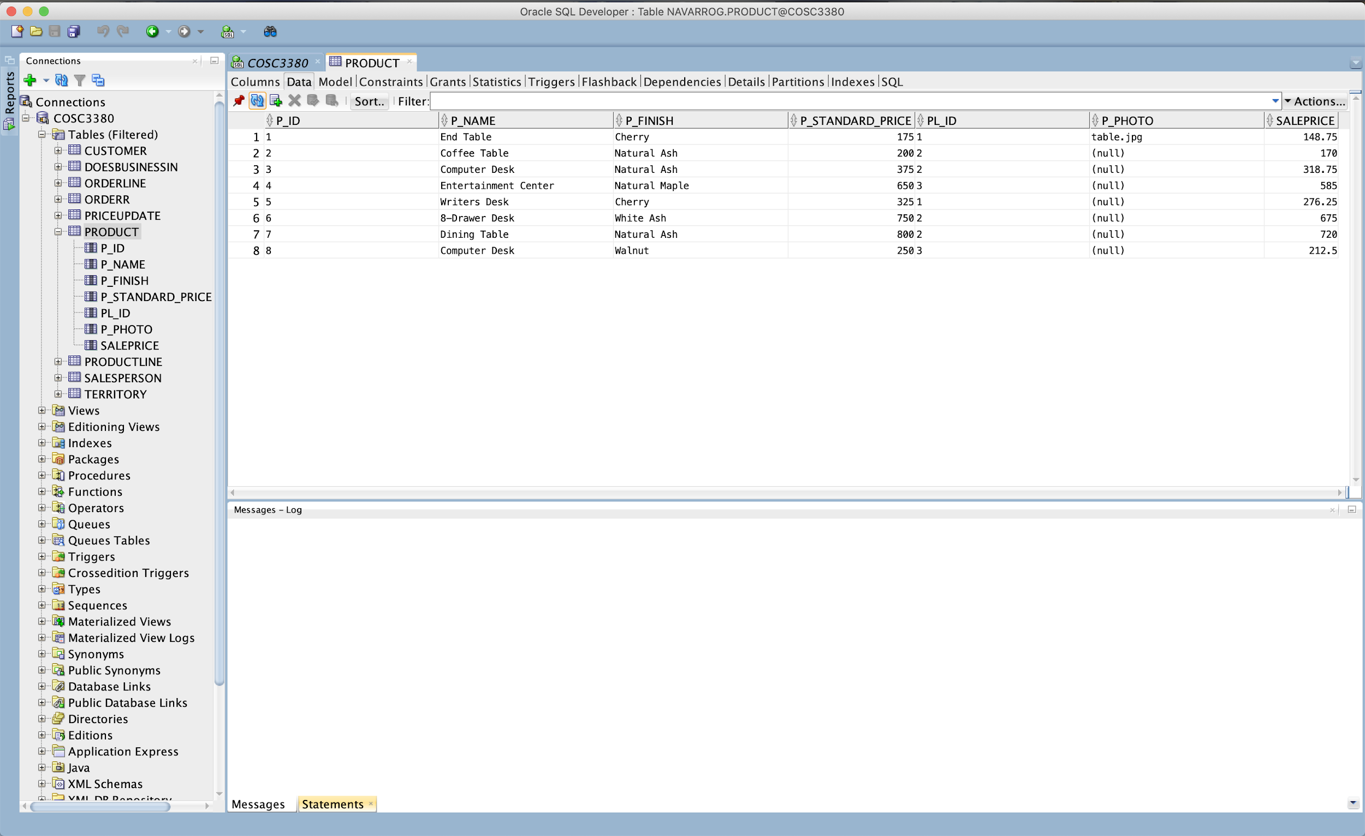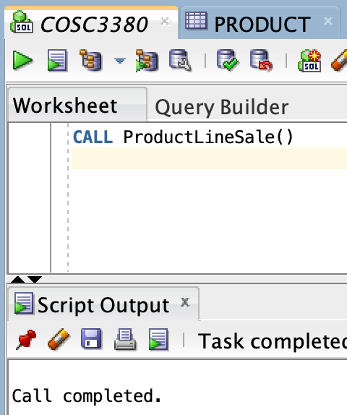

**Part 2.**  **TRIGGERS**

Consider the following example: The inventory manager needs to know (the action of being informed) when an inventory item’s standard price is updated in the Product table (the event). After creating a new table, PriceUpdates, write a trigger that enters each product when it is updated, the date that the change was made, and the new standard price that was entered.

CREATETRIGGER trigger_ name

{ BEFORE| AFTER | INSTEAD OF}

{ INSERT | DELETE | UPDATE} ON table_ name

[ FOR EACH { ROW | STATEMENT}] [WHEN ( search condition)]

< triggered SQL statement here>;

1. Write and run the trigger named **StandardPriceUpdate**

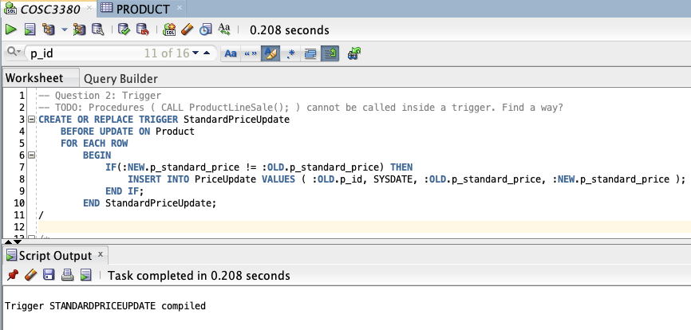

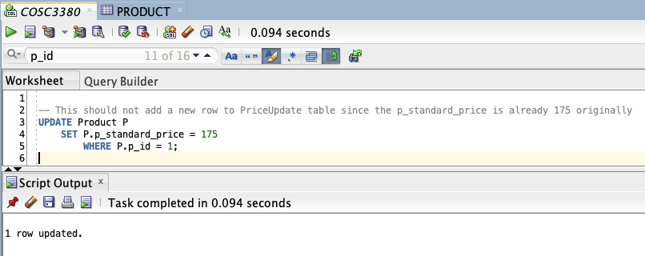

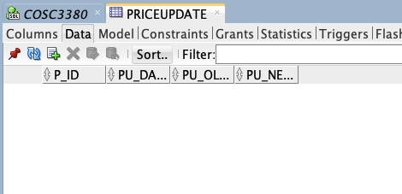

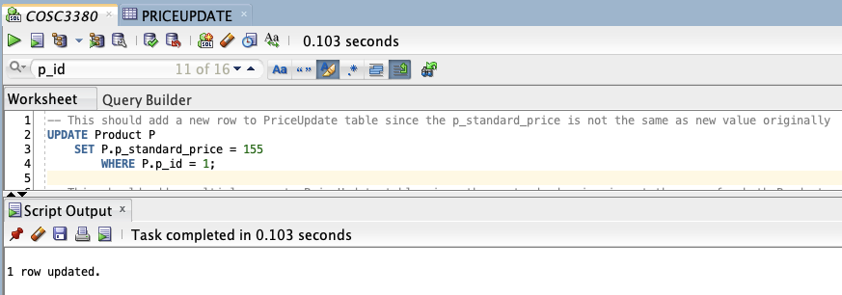

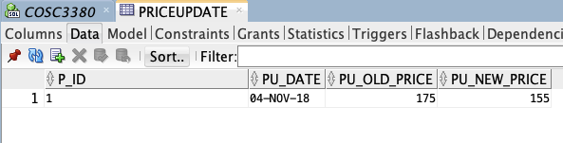

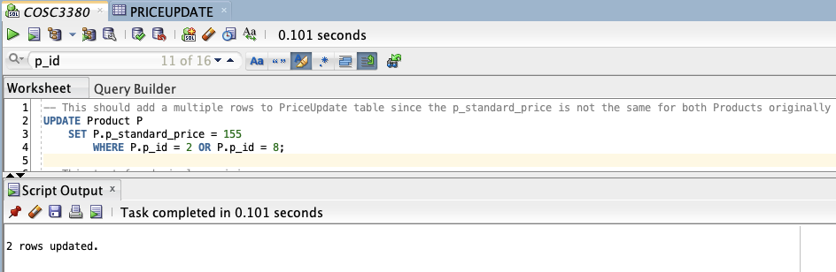

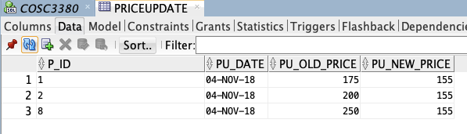

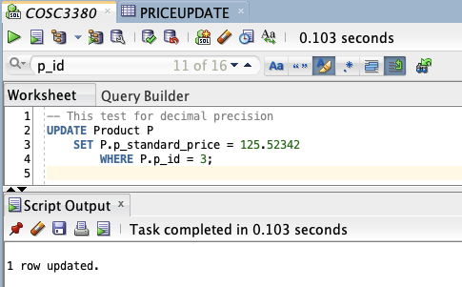

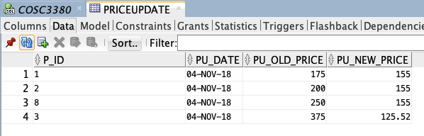

**Part** **3.** Accessing **COSC3380 Database** using PHP and MySQL.

Create a simple Web Page whose purpose is to display **SalestoDate** from the database, a report that will be used by the Product Manager (product ID, product description, #number of times the product was ordered.

